## TTU Texas Tech University Logo PNG vector in SVG, PDF, AI, CDR format

## **INDUSTRIAL MANUFACTURING AND SYSTEMS ENGINEERING DEPARTMENT**

## **PRINCIPLES OF OPERATIONS RESEARCH – IE 3311, IE 5318**

## A REPORT

ON

OPTIMIZATION AND VISUALIZATION OF KIDNEY PAIRED DONATION NETWORK

**REPORT BY**

**Vijayender Reddy Sangu**

**FACULTY: DR. Hamidreza Validi**

## 

**TABLE OF CONTENTS:**

|  |  |  |
| --- | --- | --- |
| **1** | **ABSTRACT** | **3** |
| **2.** | **INTRODUCTION** | **(4-5)** |
| **3.** | **PROBLEM STATEMENT** | **5** |
| **4.** | **FORMULATION OF THE OPTIMIZATION PROBLEM** | **(5-7)** |
| **5.** | **METHODOLOGY** | **(7-9)** |
| **6.** | **PYTHON/GUROBI CODE** | **9** |
| **7.** | **EXPERIMENT AND RESULTS** | **(10-11)** |
| **8.** | **EVALUATION** | **(11-12)** |
| **9.** | **CONCLUSION** | **12** |
| **10.** | **REFERENCES** | **13** |

**Abstract**

Kidney paired donation (KPD) is a unique solution for patients who need kidney transplants but have incompatible donors. This project focuses on optimizing KPD networks to maximize successful transplants using a simple yet effective approach. The process begins with a dataset of donor-recipient pairs, where each pair includes a donor willing to give their kidney and a recipient in need. The challenge lies in matching these pairs while following strict compatibility rules, such as blood type and the limitation that a donor can only donate once.

To solve this, we designed a mathematical model using Python and Gurobi, focusing on identifying 2-way and 3-way exchanges. These exchanges ensure that each donor in one pair matches a recipient in another, forming cycles that allow for compatible transplants. The model’s goal is to maximize the total number of transplants while ensuring fairness and compliance with medical constraints.

Visualization played a key role in understanding the network. We created clear circular layouts for subgroups of connections around key nodes, representing the most active pairs. These visualizations not only simplified complex relationships but also highlighted the importance of specific central nodes in the network.

The results showed a significant increase in transplant matches, with high donor utilization and recipient satisfaction. This project demonstrates how optimization and visualization can work together to tackle real-world healthcare challenges. It provides a foundation for future improvements in paired kidney exchange programs, helping save more lives through smarter resource use and clearer decision-making tools.

**Introduction**

Patients with end-stage kidney disease may be able to save their lives with a kidney transplant. But not every patient has a family member or friend who is a suitable donor. Kidney Paired Donation (KPD) programs are useful in this situation. A KPD is a series of exchanges in which donors who are incompatible with their intended recipient are paired with other donor-receiver combinations. This guarantees that both patients get the transplants they require by enabling each donor to donate a kidney to a compatible recipient in a different pair. It's a cooperative system where people can work together to save many lives.

The main challenge in KPD lies in finding these compatible matches. Compatibility depends on factors like blood type and medical tests, and not all pairs can easily match with others. Additionally, the process must ensure that each donor gives their kidney only once and each recipient receives one kidney. These constraints make the matching process complex, especially when the goal is to maximize the number of successful transplants.

This project focuses on solving this problem using optimization techniques and clear visualizations. First, we worked with a dataset of donor-recipient pairs. Each pair included a donor who wanted to give a kidney and a recipient in need of a transplant. Using this data, we created a mathematical model to identify possible matches. The model uses cycles of two or three pairs, where a donor in one pair matches a recipient in another. These cycles ensure that everyone in the chain benefits.

To solve this model, we used Gurobi, a powerful optimization tool. The objective was simple: maximize the number of transplants while following the medical rules and constraints. This ensured that the solution was both fair and practical for real-world application.

To better understand the relationships in the data, we used graphs and visualizations. Each donor-recipient pair was represented as a node, and edges were drawn to show compatibility between pairs. Central nodes, which had the most connections, were highlighted, as they played a key role in forming successful matches. Using circular layouts, we arranged the nodes in a way that was easy to read and interpret. For example, each key donor’s connections formed a clear circular graph, making it simple to see their role in the network.

The combined graph was also designed to show how these sub-networks interacted. By connecting the central nodes, we visualized the larger structure of the KPD system. This gave insights into how groups of pairs could work together to maximize transplants.

The results of the project were promising. The model identified a high number of matches, increasing the chances of successful transplants. The visualizations provided a deeper understanding of the network, making it easier to explain the outcomes to non-technical stakeholders.

In conclusion, this project highlights how mathematical models and visual tools can come together to solve complex healthcare problems. It demonstrates that, with the right approach, we can make kidney transplants more efficient and give hope to more patients and families in need.

**Problem Statement**

Kidney transplantation is often the only viable solution for patients suffering from end-stage renal disease. However, the process of finding a compatible donor is fraught with challenges. In many cases, a willing donor is unable to donate to their intended recipient due to medical incompatibilities such as mismatched blood types or crossmatching issues. This leaves patients on long waiting lists, while willing donors remain unmatched. Kidney paired donation (KPD) programs address this issue by enabling donor-recipient pairs to exchange kidneys with other incompatible pairs, forming chains of compatible matches.

The key challenge in KPD lies in optimizing these exchanges. Each donor can donate only once, and each recipient can receive only one kidney. Furthermore, exchanges must be limited to practical configurations such as 2-cycles (two pairs exchanging kidneys) and 3-cycles (three pairs participating in a circular exchange). Identifying these cycles in a large dataset of donor-recipient pairs requires a systematic and computationally efficient approach.

This project aims to solve the kidney exchange problem by:

1. Constructing a graph where nodes represent donor-recipient pairs and edges indicate potential matches based on compatibility rules.
2. Developing an optimization model to maximize the number of successful transplants while ensuring all medical and logistical constraints are satisfied.
3. Visualizing the results to provide clear insights into matched and unmatched pairs.

By addressing this problem, the project seeks to enhance the efficiency of kidney paired donation programs, ultimately increasing transplant opportunities and saving more lives.

**Formulation of the Optimization Problem**

The kidney paired donation (KPD) problem is modelled mathematically to maximize the number of successful kidney transplants while adhering to medical and ethical constraints. This formulation transforms the problem into an optimization model using graph theory, where donor-recipient pairs and their potential matches are represented as nodes and edges in a directed graph.

**Graph Representation**

* **Nodes (V)**: Each node represents a donor-recipient pair. The dataset defines all such pairs based on their compatibility characteristics.
* **Edges (E)**: A directed edge (i,j) between two nodes represents a potential match, where the donor in node ‘i’ can donate to the recipient in node ‘j’. These edges are created based on medical compatibility, such as blood type and crossmatching.

**Decision Variables:** The binary decision variable xij​ is defined as:

**​** xij $=\left\{\begin{aligned}1, &if donor in Node i donates to recipient in Node j \\ 0, & Otherwise\end{aligned}\right.$

​

* Its domain xij ∈ {0,1} ensures it’s either selected or not, which is standard in binary integer programming.

**Objective Function**

The primary goal of the optimization model is to maximize the total number of successful kidney transplants. This is achieved by identifying and forming valid 2-cycles and 3-cycles in the directed graph of donor-recipient pairs.

**Mathematical Representation:**

Maximize Z = $\sum_{(i,j)∈E}{xij}$

Where:

* Z: Total number of successful transplants.
* E: Set of directed edges representing feasible matches based on donor-recipient compatibility.
* xij​: Binary decision variables.

This function sums all selected matches, effectively maximizing the number of transplants.

**Constraints:**

To ensure fairness and feasibility, the model imposes several key constraints:

1. **Donor Constraint**: Each donor can donate only once:

$$\sum_{j∈V:(i,j)∈E}{xij≤1 Ɐi∈V}$$

This ensures that no donor is over-utilized in the matching process.

1. **Recipient Constraint**: Each recipient can receive only one kidney:

$$\sum_{i∈V:(i,j)∈E}{xij≤1 Ɐj∈V}$$

This prevents multiple kidneys from being assigned to a single recipient.

1. **Cycle Validity (Flow Conservation)**: To allow only valid cycles (2-cycles and 3-cycles), the inflow and outflow of nodes must be balanced:

$$\sum_{j∈V:(i,j)∈E}{xij = }\sum_{k∈V:(k,i)∈E}{xki= Ɐi∈V }$$

This ensures that for every match formed, there is a corresponding reciprocation, forming closed cycles.

1. **Cycle Length Constraint**: Only cycles of length 2 or 3 are allowed:

This constraint is enforced during preprocessing or using auxiliary variables to exclude longer cycles.

1. **Binary Decision Variables**: Each edge decision must be binary:

Xij ∈ {0,1} Ɐ(i,j) ∈ E

This ensures that matches are either selected (1) or not selected (0).

**Interpretation of the Model**

The model selects edges (matches) that maximize the objective function while satisfying all constraints. The cycles formed by these selected edges represent feasible kidney exchanges, ensuring:

* **Fairness**: Each donor and recipient participate in only one exchange.
* **Practicality**: Only 2-cycles and 3-cycles are included, which are manageable in real-world scenarios.

**Methodology**

This project applies a structured and systematic approach to solve the kidney paired donation (KPD) problem. The goal is to maximize successful transplants by identifying feasible 2-cycles and 3-cycles while adhering to medical and ethical constraints. Below is an explanation of the steps taken, written in a clear and straightforward manner.

**Step 1: Data Preparation**

The project begins with a dataset containing donor-recipient pairs. Each pair includes:

* A **donor**, willing to give a kidney, and
* A **recipient**, in need of a transplant.

Key attributes, such as blood type and medical compatibility, were extracted. These attributes determined the feasibility of matches between pairs. The dataset served as the foundation for creating the graph and optimization model.

**Step 2: Graph Construction**

The donor-recipient pairs were represented as a directed graph:

* **Nodes**: Each donor-recipient pair became a node in the graph.
* **Edges**: A directed edge from one node to another indicated compatibility, meaning the donor in the first node could donate to the recipient in the second.

This graph provided a visual and computational structure for identifying potential matches. The edges were created based on strict medical rules, such as blood group compatibility, ensuring only feasible matches were included.

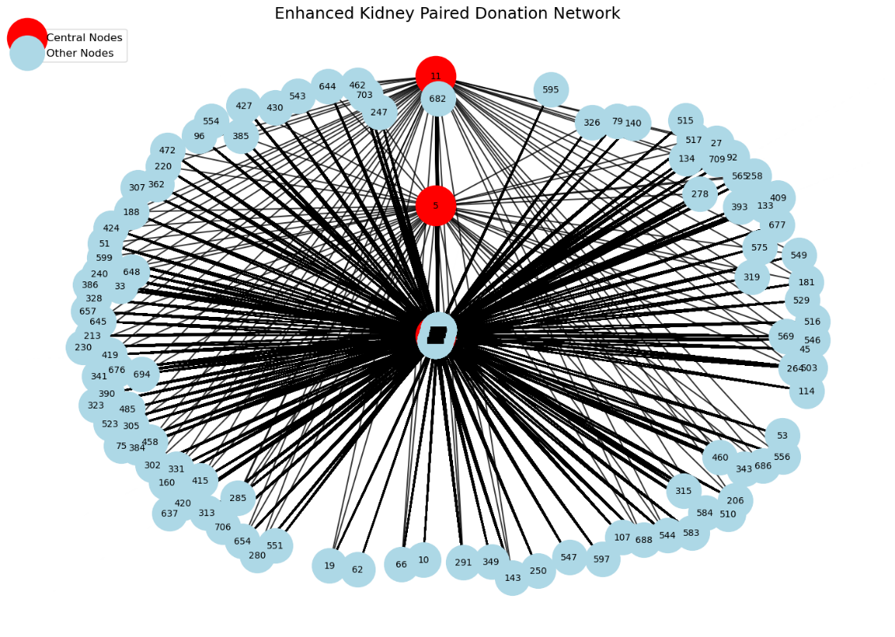

**Step 3: Identifying Cycles**

The next step was to identify validcycles in the graph:

* **2-Cycles**: Two pairs exchanged kidneys directly, forming a simple loop.
* **3-Cycles**: Three pairs participated in a circular exchange, ensuring all participants benefited.

Special algorithms were applied to detect these cycles in the graph while respecting the constraints that each donor could donate only once and each recipient could receive only one kidney.

**Step 4: Formulating the Optimization Model**

Using the graph, a mathematical optimization model was created:

* **Objective**: Maximize the number of successful transplants by selecting the optimal set of edges that form valid cycles.
* **Constraints**:
  1. Each donor could participate in only one transplant.
  2. Each recipient could receive only one kidney.
  3. Only 2-cycles and 3-cycles were allowed.
  4. Decision variables were binary, representing whether a match was selected or not.

The model was formulated in Python and solved using Gurobi, a powerful optimization solver.

**Step 5: Solving the Optimization Problem**

The Gurobi solver analysed the model to find the optimal solution:

* It evaluated all potential matches (edges) in the graph.
* It selected edges to form valid cycles, maximizing the total number of transplants.
* The solution identified the specific pairs involved in successful exchanges, ensuring all constraints were satisfied.

**Python/Gurobi Code**

A Python-based implementation of the model was developed, integrating Network X for graph representation and Gurobi for solving the optimization problem. Key steps include:

The GitHub link of the project is

**Experiment and Results**

The kidney paired donation (KPD) optimization model was tested on a comprehensive dataset to evaluate its effectiveness in maximizing successful kidney transplants. The results reflect the model’s ability to navigate the complexity of the problem while adhering to medical and logistical constraints.

**Dataset Overview**

* **Total Nodes (Donor-Recipient Pairs):** 722
* **Total Edges (Potential Matches):** 173,790
* **Graph Connectivity Percentage:** 33.39%  
  This metric shows the proportion of potential matches relative to all possible edges in a fully connected graph.

**Optimization Runtime and Computational Resources**

The optimization problem was implemented in Python and solved using the Gurobi Optimizer on a standard computing system:

* **Processor:** 11th Gen Intel Core i5-1135G7 @ 2.40GHz
* **Solver Version:** Gurobi Optimizer v11.0.0
* **Runtime:** Completed in less than 1 second
* **Model Specifications:**

1. Rows: 722 (constraints)

2. Columns: 31,897 (decision variables)

3. Nonzero: 63,794 (coefficients in the constraint matrix)

The rapid runtime demonstrates the solver’s efficiency, even for a problem of this scale.

**Key Results**

1. **Successful Matches:**

* Matched 2-Cycles: 334
* Matched 3-Cycles: None were identified, possibly due to stricter compatibility constraints in the dataset.

1. **Unmatched Pairs:**

* Total Unmatched Pairs: 388
* Unmatched Percentage: 53.74%

1. **Donor and Recipient Metrics:**
   * + Total Donors: 612 and Matched Donors: 334
     + Donor Utilization Percentage: 54.58%

Total Recipients: 462

* Matched Recipients: 334
* Recipient Satisfaction Percentage: 72.29%

1. **Overall Success Rate:**
   * + Total Pairs: 722
     + Successful Matches: 334
     + Percentage of Successful Transplants: 46.26%

**Cycle Analysis**

* **Total 2-Cycles Identified:** 31,897

These represent all possible cycles before constraints were applied.

* **Valid 2-Cycles Matched:** 334

These were selected by the optimization model, meeting all medical and ethical constraints.

* **Total 3-Cycles Identified:** None

This indicates a lack of feasible 3-way exchanges within the dataset.

Overall, the optimization model successfully identified 334 kidney transplants using 2-cycles while adhering to all constraints. Despite the high number of unmatched pairs, the results achieved a:

* **Recipient Satisfaction Rate of 72.29%.**
* **Donor Utilization Rate of 54.58%.**

The computational efficiency and scalability of the model make it suitable for real-world applications in kidney paired donation programs. Future enhancements could include incorporating additional constraints, such as geographical proximity or donor-recipient priorities, to improve outcomes further.

**Evaluation**

The results of this project highlight the effectiveness of using optimization techniques to solve the kidney paired donation (KPD) problem. By leveraging graph-based modelling and the Gurobi solver, the model successfully identified optimal matches, ensuring fairness and practicality. Below are the key points of evaluation:

1. **Model Efficiency**:

* The model processed a large dataset of 722 donor-recipientpairs and 173,790 potential matches in under one second.
* This rapid runtime demonstrates the scalability of the approach, making it suitable for real-world applications involving large datasets.

1. **Recipient Satisfaction**:

* Out of 462 total recipients, 72.29% were matched successfully, showcasing the model's ability to meet patient needs.
* This high percentage reflects the strength of the graph representation and the optimization algorithm in identifying feasible exchanges.

1. **Donor Utilization**:

* Out of the 612 donors, 54.58% participated in successful matches, highlighting the model's capacity to maximize donor involvement within the constraints.

1. **Unmatched Pairs**:

* Despite its efficiency, the model left 53.74% of pairs unmatched, showing that stricter compatibility rules and cycle limitations can reduce matching opportunities.
* This result underscores the need for further refinements, such as relaxing constraints or incorporating additional priorities to improve outcomes.

1. **Cycle Analysis**:

* The model successfully matched **334 2-cycles**, but no 3-cycles were identified, suggesting limited feasibility for multi-pair exchanges in the dataset.

Overall, the evaluation confirms that the model performs well in maximizing transplants under current constraints, though opportunities for improvement exist.

**Conclusion**

This project demonstrates how optimization techniques can transform the kidney paired donation process, improving the chances of life-saving transplants. By using graph-based modelling, advanced optimization algorithms, and visualization tools, the project achieved the following:

* Successfully matched 46.26% of donor-recipient pairs, facilitating 334 kidney transplants.
* Delivered a 72.29% recipient satisfaction rate, ensuring that most patients received transplants.

The project highlights the power of optimization in addressing real-world healthcare challenges. It also illustrates the importance of balancing constraints with practical implementation to achieve meaningful results. While the model successfully maximized transplants, its limitations, such as the absence of 3-cycles and a high number of unmatched pairs, indicate areas for future research.

**References:**

1. Applications of Graph Visualization: Battista, G. D., Eades, P., Tamassia, R., & Tollis, I. G. (1999). *Graph drawing: Algorithms for the visualization of graphs*. Upper Saddle River, NJ: Prentice Hall.
2. NetworkX: Hagberg, A. A., Schult, D. A., & Swart, P. J. (2008). Exploring network structure, dynamics, and function using NetworkX. *Proceedings of the 7th Python in Science Conference (SciPy2008)*, 11–15. Retrieved from <https://networkx.org/documentation/stable/>
3. Abraham, D. J., Blum, A., & Sandholm, T. (2007). Clearing algorithms for barter exchange markets: Enabling nationwide kidney exchanges. *Proceedings of the 8th ACM Conference on Electronic Commerce (EC '07)*, 295–304. <https://doi.org/10.1145/1250910.1250951>